The variables we chose for this assignment were:
year | id_ | age | hrs1 | wrkstat | educ | sex | rincome | happy | marital | polviews
We choose this data because it gives a spread of basic demographic information, as well as information about the participants’ jobs and overall well being. We felt that to get a complete picture of the participants, categories such as age and sex would allow us to understand a little more demographically about each participant. While not explicitly demographic, we also felt that marital status is an important piece of information to know. This can greatly alter responses and influence the level of work people perform or are able to perform. For example, someone who is married may have different financial pressures or time constraints compared to someone who is single or divorced.
Further information about the participant that is not explicitly demographic and also does not have to do with their job, but allows us to understand them as person includes highest education level (educ) and their political views on a scale (polviews). Education level is something that really interested us, especially whether or not this impacts participants’ feelings and opportunities to gain a higher income. Political views is something also interesting and slightly controversial. This part will be interesting to track over time. This survery began in 1972 and has data up until 2024. The definitions of “liberal” and “conservative” have changed a lot over time and recently have become even more polarized, so it will be intersting to see if this impacts things like education level obtained, since higher education has become a hot topic in politics recently. We chose this because we thought it would be interesting to see if these correlations between political parts, education, and income actually exist or if they are just speculated.
For the variables that explicitly have to do with their work, we decided to look first at work status (wrkstat) to determine what kind of work paricipants did, hours worked last week (hrs1) and respondent income (rincome). We thought that these would give the best understanding of what a participant’s work life is like. While there were more descriptive variables directly about their occupation or specific questions about workplace conditions, we felt that in order to effectively analyze this data it would be better to extract data that can apply to all jobs. This way we can get definitive answers from most participants and we are able to analyze the responses more cleanly. It will be interesting to see things like: if you have a higher education level, can you work fewer hours and still have a high income? Or does marital status affect how many hours someone works? Questions like this are things we often unconsciously think about, but analyzing this data will allow us to truly look into it with real numbers. We chose respondent income as opposed to just income because we thought it would be difficult to compare a married person’s household income to an indvidual’s income if the person was not married. We felt respondent income would be more applicable and consistent with other variables as all other categories are specifically about the individual. We further chose hrs1 instead of hrs2 (average hours work a week), because we felt that having a participant just think about last week and comparing those would be more accurate than having them try to on-the-spot average over an entire year. Finally, we wanted to look at a category regarding the respondents' feelings or attitudes. This was hard to pick because there are so many questions that pertain to this in the GSS. We ended up choosing the category asking about a participant's happiness (happy) because we found that the options for answers were very clear and straightforward, and it was used since the survery began, so we have lots of data to work with. Happiness also felt like a good outcome variable to explore, we’re interested in seeing if factors like income, education, work hours, or marital status correlate with how happy people report being. This could give us some interesting insights into what contributes to people's well-being.
Combined visualizations & Analysis (for clarity)
Question: If you have a higher education level, can you work fewer hours and still have a high income?
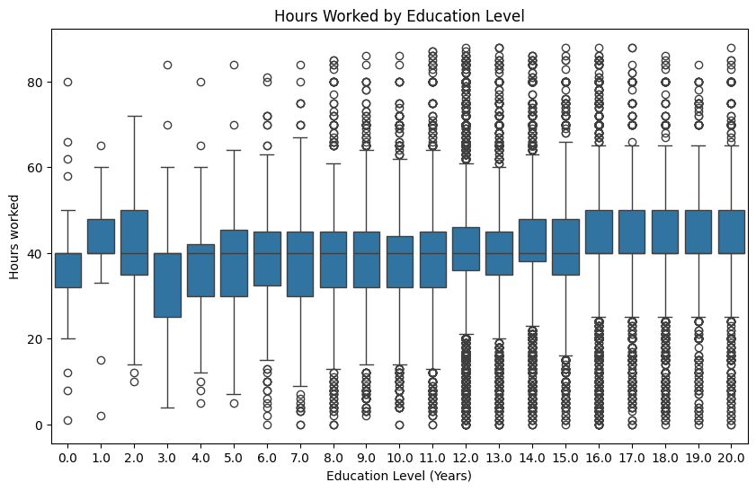
As you can see from the plot, there was an increase in hours worked as level of education increased. We also calculated numerical summaries to reflect this, which indicated a slight upward shift in hours worked by level of education. This could be due to a number of things including as years of education increase, age also may have increased and thus the number of hours worked a week may be more purely by being in a more senior position that requires more time in the office. An adult may more likely be working a full-time job than a teenager, for example. The trend in this plot wasn’t very aggressive, but you can see a slight linear increase as years of education increase. However, you can see great variation in each education bin, which may be due to the shear size and variation of the data itself and the fact that the data was taken over such a large period of time where the amount of hours one works has changed significantly.
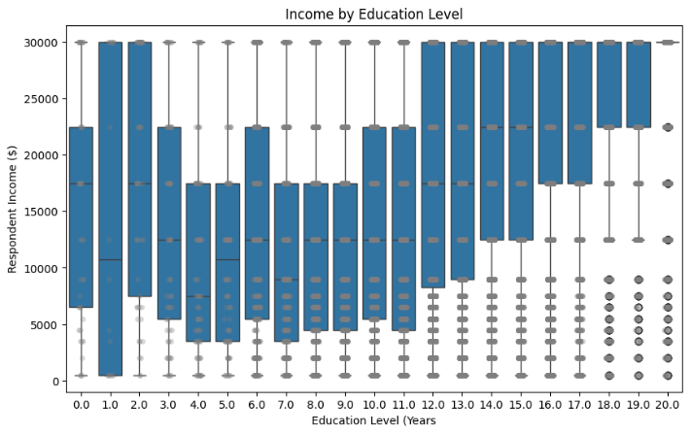
The trend in this plot is a little bit more obvious, indicating that income level may correlate to higher education levels. You can see while there are some lower outliers there are significantly less outliers than the last plot indicating a more reliable correlation here.
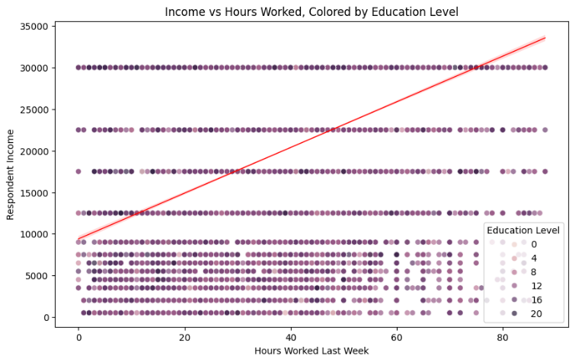
From this plot, the spearman correlation between hours worked and income was observed to be 0.36. This does not indicate a very strong correlation necessarily, but based on the data, it shows a slight relationship between the two but nothing super telling.
In conclusion:
QUESTION: Does marital status affect how many hours someone works?
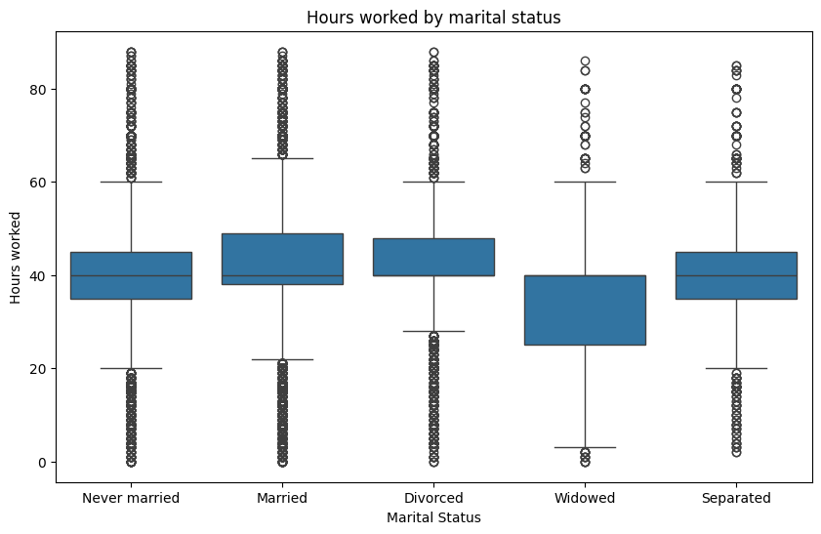
Here we used a boxplot to identify trends between work hours and marital status. This gave us more insight into whether a respondent’s marital status has more influence over their hours worked, or vice versa. Interestingly, married respondents reported higher mean hours worked compared to respondents who were never married. Additionally, respondents who were widowed reported the lowest mean hours worked. This could be explained by the typical age of a widowed person, as you would expect a person’s spouse to pass away at an age where they may have started to work part-time and may have retired from their full time job or other circumstances that come with age.

QUESTION: Does income, education, work hours, or marital status correlate with how happy people report being?
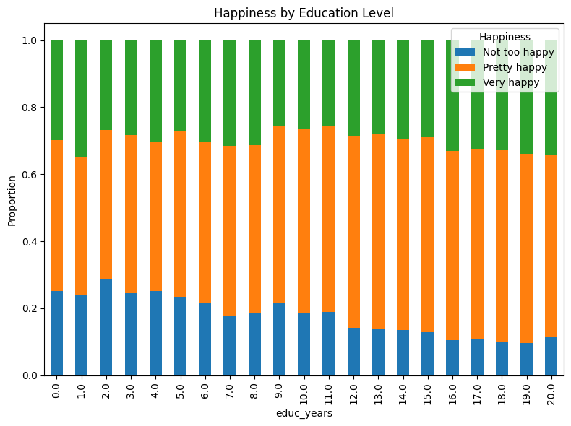
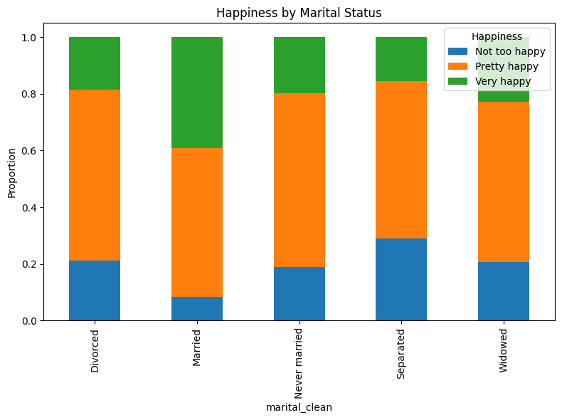
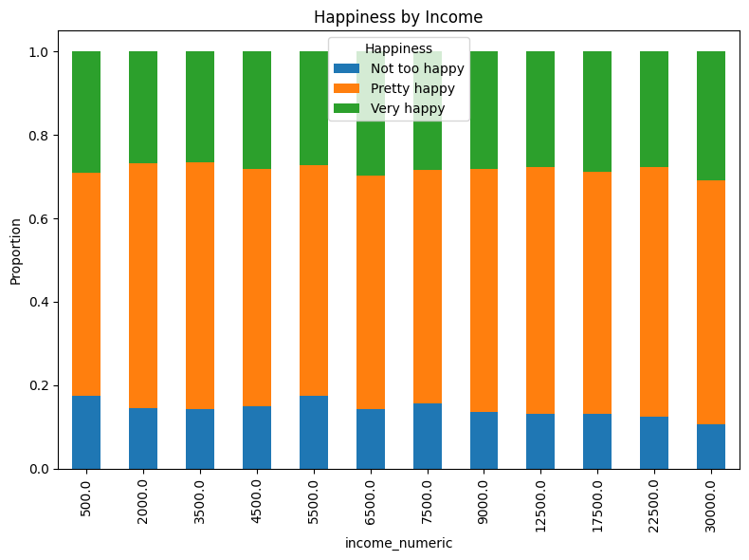
In order to discuss happiness by income, marital status, and education level, we plotted three stacked bar charts. In the plot comparing happiness to income level, you can see a slight decrease in the number of “not too happy” respondents as income level rises. In comparing happiness to marital status, there was a much more drastic visual change than happiness by income. This corresponded with trends we see socially, especially in the United States. It seems as though a greater proportion of married respondents consider themselves very happy. What is pleasing to see is that although there is a change across marital status, overall there is a fairly low proportion of respondents who consider themselves not too happy. This was a comparison we were very interested in because social aspects can, and often do, affect a person’s work ethic, routine, goals, etc. Then, because we were able to see slight trends in happiness level by marital status, we wanted to look at happiness by education. This showed a similar trend to happiness by income level, which we sort of expected. It was slightly more drastic than income’s impact on happiness, showing a decrease in the proportion of respondents who consider themselves “not too happy” as education level increased. This could be due to a number of things that a respondent might consider happiness inducing. A person may be more content with a higher income level when they feel they can better support themselves and do the things they love, or they may be more in tune with their emotions and have a better understanding of well being at a higher education level, etc. These trends behaved as we expected they might, indicating that respondents may feel happier as a married person or as a person with higher education level.
QUESTION: Does political party effect highest education received?
Political Party Response | Count
Moderate | 25140
Slightly conservative | 9977
Conservative | 9877
Slightly liberal | 8268
Liberal | 8044
Extremely conservative | 2351
Extremely liberal | 2221

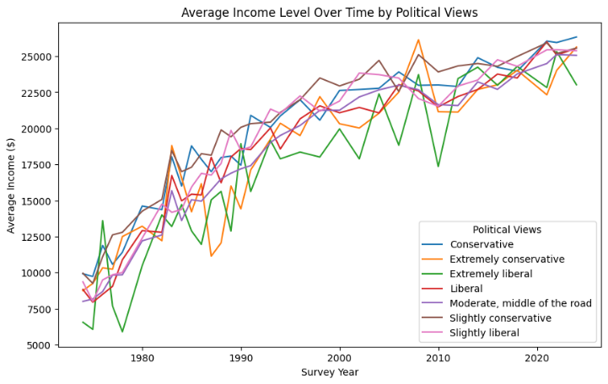
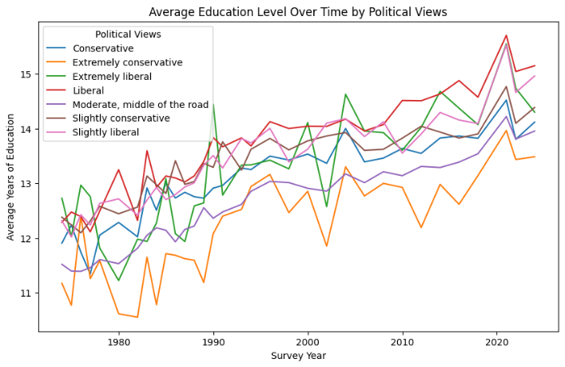
In this final section, we examined how political party may play a role in survey responses. We first simply identified the # of responses by party, because we were curious to see if there were any trends there. There was a much larger number of respondents in the moderate category, and far fewer in either of the extremes. This helped to then inform our analysis of political party responses to average years of education as well as average income.
We wanted to look at these categories across survey years to understand how political views may or may not affect education and income over time. Across both analyses, we saw an upward trend in both education and income from the 1980’s to 2020. This is what we might expect simply due to how society has evolved economically and socially. What was interesting was that there were slight trends in political views across education and income level. We saw a higher level of education in liberal respondents (extreme liberal, liberal) across survey years, but saw lowered average income for extremely liberal respondents relative to other parties.

Appendix A. Each variables specific question and answer choices.
Wrkstat:
Q: Last week were you working full time, part time, going to school, keeping house, or what?
A: No answer
Do not Know/Cannot Choose
Skipped on Web
Working full time
Working part time
With a job, but not at work because of temporary illness, vacation, strike
Unemployed, laid off, looking for work
Retired
In school
Keeping house
Other

Hrs1
Q: IF WORKING, FULL OR PART TIME: How many hours did you work last week, at all jobs
A: I: inapplicable (respondant not eligible to answer i.e. for this fi they didnt work full or part time jobs)
No answer
Do not Know/ Cannot Choose
Skipped on Web
0-89 (all separate)
89+

Age
Q: RESPONDENT'S AGE
A: A: I: inapplicable (respondent not eligible to answer i.e. for this if they didn't work full or part time jobs)
No answer
Do not Know/ Cannot Choose
18-89
89+

Educ
Q: What is the highest grade in elementary school or high school that (you/your father/ your mother/your [husband/wife]) finished and got credit for? CODE EXACT GRADE.
B. IF FINISHED 9th-12th GRADE OR DK*: Did (you/he/she) ever get a high school diploma or a GED certificate? [SEE D BELOW.] [See REMARKS]
C. Did (you/he/she) complete one or more years of college for credit--not including schooling such as business college, technical or vocational school? IF YES: How many years did (you/he/she) complete?
Do you (Does [he/she]) have any college degrees? (IF YES: What degree or degrees?) CODE HIGHEST DEGREE EARNED.
A:
NO answer
Do not Know/Cannot Choose
No formal schooling
1st-12th grade (all separate)
1-7 years of college
8 or more years of college

Sex
Q: CODE respondents sex (workers did this)
A: Inapplicable
No answer
Do not Know/Cannot Choose
Skipped on Web
Female
Male
Income
Q: id you earn any income from (OCCUPATION DESCRIBED IN OCC-INDUSTRY) in [the previous year]?
Yes ............. (ASK RINCOME)
No .............. [See REMARKS]
A. IF YES: In which of these groups did your earnings from (OCCUPATION IN OCC) for last year--[the previous year]--fall? That is, before taxes or other deductions. Just tell me the letter.
A:
Inapplicable
No answer
Do not Know/Cannot Choose
Skipped on Web
Refused
LT $1000
$1000 to 2999
$3000 to 3999
$4000 to 4999
$5000 to 5999
$6000 to 6999
$7000 to 7999
$8000 to 9999
$10000 to 14999
$15000 to 19999
$20000 to 24999
$25000 or MORE
Happy
Q: Taken all together, how would you say things are these days--would you say that you are very happy, pretty happy, or not too happy?
A:
Inapplicable
No answer
Do not Know/Cannot Choose
Skipped on Web
Very happy
Pretty happy
Not too happy

Marital
Q: Are you currently--married, widowed, divorced, separated, or have you never been married?
A:
No answer
Do not Know/Cannot Choose
Skipped on Web
Married
Widowed
Divorced
Separated
Never Married
Polviews
Q: We hear a lot of talk these days about liberals and conservatives.
I'm going to show you a seven-point scale on which the political views that people might hold are arranged from extremely liberal--point 1--to extremely conservative--point 7. Where would you place yourself on this scale?
A:
Inapplicable
No answer
Do not Know/Cannot Choose
Skipped on Web
Extremely liberal
Liberal
Slightly liberal
Moderate, middle of the road
Slightly conservative
Conservative
Extremely conservative

